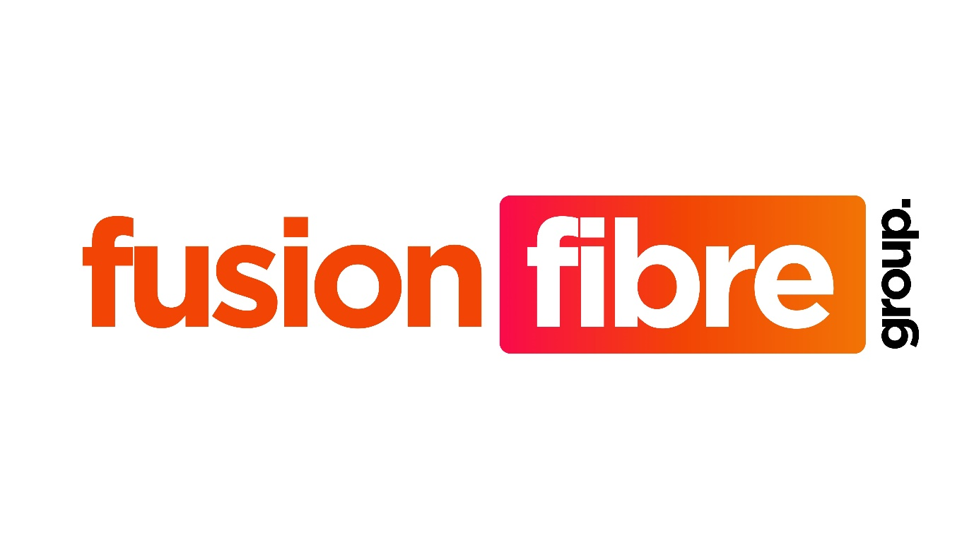

Fusion Fibre Group
Refer a Friend Terms and Conditions

- Application and Interpretation
  - These Terms and Conditions shall apply in where You have successfully been granted a credit to Your account in accordance with the Refer a Friend offer, in accordance with Clause 4.1 of these terms and conditions.
  - The definitions within these terms and conditions shall have the same meaning as prescribed within the Fusion Fibre Group Services Terms and Conditions.
- Promotion Description
  - You are eligible to opt for Refer a Friend if;
    - Your address is within a valid Partner (Freedom Fibre only) area, which shall be confirmed by Fusion Fibre Group when processing the referral order.
    - Your referee(s) are within a valid Partner (Freedom Fibre only) area, which shall be confirmed by Fusion Fibre Group when processing the referral order.
  - You and Your referee(s) must be connected and Your Service(s) live before the 31st October 2025.
  - In order to qualify for the credit, You and Your referee must have been installed for 30 (thirty) calendar days or more, and not be in arrears on their account. We shall not discuss the payment status of any customer with a referrer (or vice versa).
  - We shall automatically apply a £50.00 (fifty) each to Your account following the verification steps outlined within Clause 2.3, per referral.
  - We shall automatically apply a £50.00 (fifty) each to Your referrals account following the verification steps outlined within Clause 2.3.
- Exclusions and Clarifications
  - Refer a Friend shall not apply;
    - With any other promotion, discount, referral or other sales offers that may be utilised by Fusion Fibre Group from time to time.
    - If We reasonably consider that the information You have provided to Us is incomplete or ineligible then We reserve the right to refuse such claims.
    - If You dispute the application of the referral credit, We reserve the right to investigate such claims. Our decision on any Refer a Friend dispute is final.
- Application
  - You shall complete the form that is located on Our website, which shall be processed by Us.
  - In submitting referrals, You confirm that You have the referees (the party being referred) permission to share their information for the purposes of providing the Services to them, and that We have the right to contact them for the purposes of agreeing a contract with them.
  - You do not have to be an existing connected customer of Fusion Fibre Group, however in order to claim the Refer a Friend promotion, You must enter a Contract for the Services for Your broadband connection, and have been installed for 30 (thirty) calendar days or more, and not be in arrears on Your account.
- Cancellation
  - If You cancel Your Service, whensoever cancelled, You shall forfeit any remaining credit on Your account should there be any credit remaining. We further confirm that We shall not reimburse You by any other form for such remaining credit.
  - If We reasonably determine that You have submitted false or misleading information or consider Switch Connect to have been misused, We reserve the right to remove the credit and/or cancel Your Services.
  - If We terminate Your Services due to non-payment, We reserve the right to withdraw any remaining account credit from consideration when calculating Your Early Termination Fee.

